PARTS ON ORDER

----------------------------------------------

**PAM8403 Amp Volume Adjustment Double Track Power Amplifier Module CP08008 JQ**

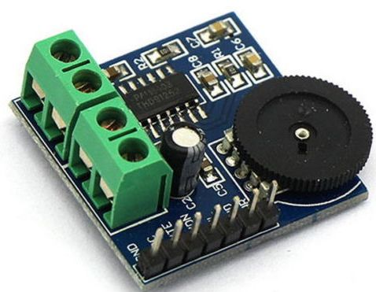

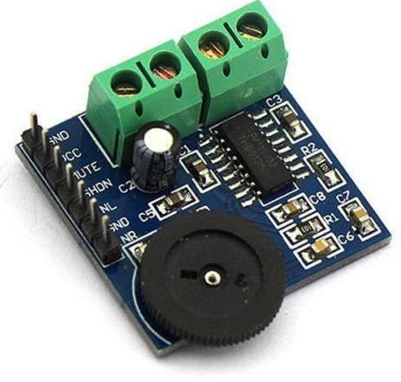

**Description:**

**1. An onboard PAM8403 audio amplifier chip, 3W * 2 Stereo filterless Class-D audio amplifier**

**2. Then 2-way onboard 5.08 (mm) pitch 2P terminal, respectively, left and right channel output wiring**

**3. The chips are pin is already leads to facilitate the external device control**

**4. Working voltage: 5V**

**5. Board size: 30 (mm) x30 (mm)**

**Package:**

**1x PAM8403 two-channel Double Track Power Amplifier Module**

**Not Retail Box .Packed Safety in Bubble Bag**

----------------------------------------------

**1Pcs Wireless Transceiver Module NRF24L01+ 2.4GHz Antenna For Arduino Hot BQ**

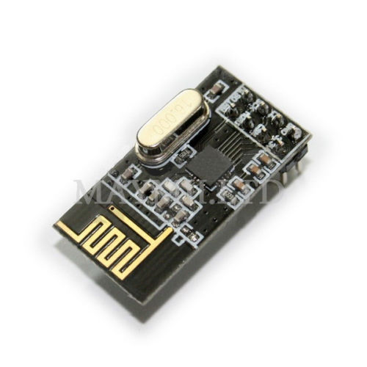



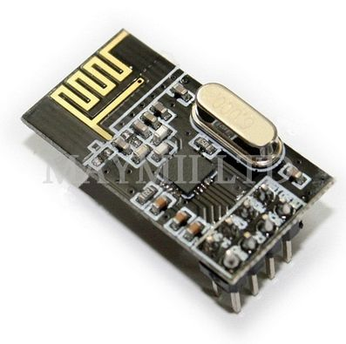

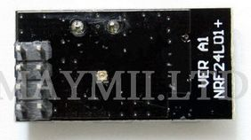

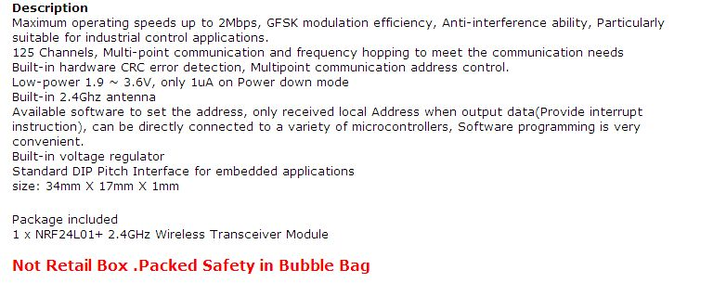

----------------------------------------------

[**20141119 IR Remote Control - Aruino**](https://docs.google.com/document/d/1OZe4uGwLvfeUGycHqca3pRWP6RYU8c6uGMnlTBvFiBU/edit?usp=sharing)

----------------------------------------------

**Miracast WIFI Display Receiver Dongle Streaming A9 Airplay DLNA HDMI 1080P iPush**

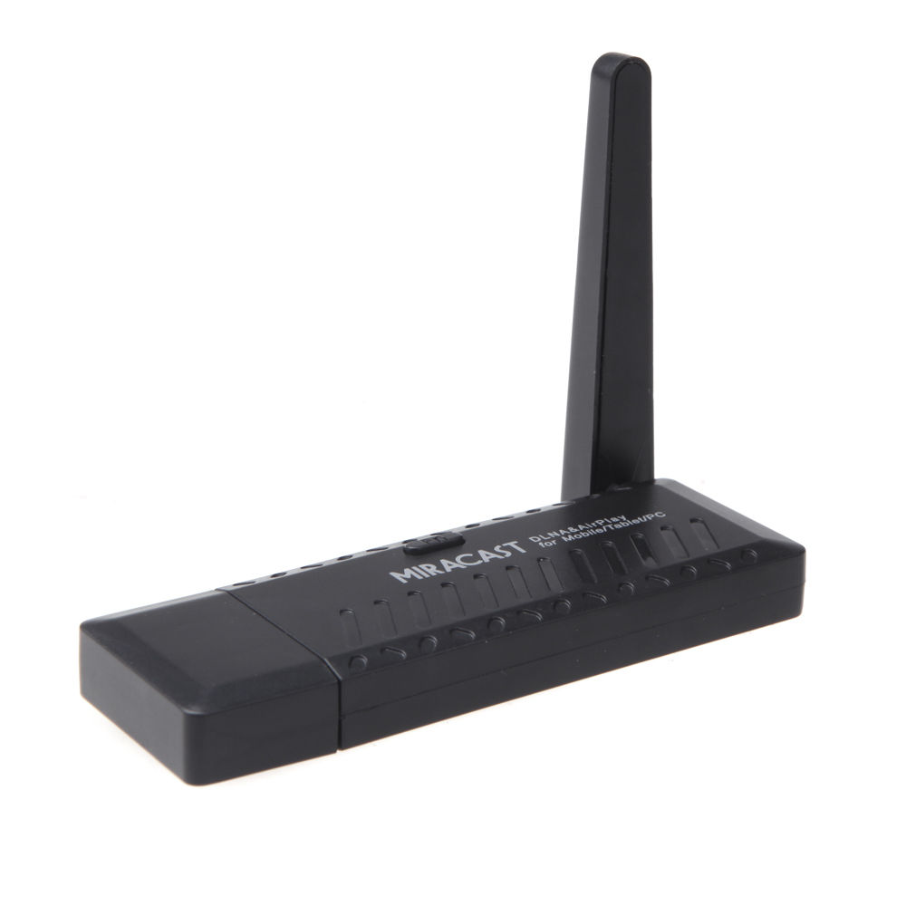

**ebay part 111372247444**

----------------------------------------------

Estimated delivery **Thursday, Oct. 30**

#### [**3ft 6ft 10ft 15ft 25ft 50ft SVGA SUPER VGA Male Monitor Cable 3.5mm audio Lot**](http://www.ebay.com/itm/121428275890)

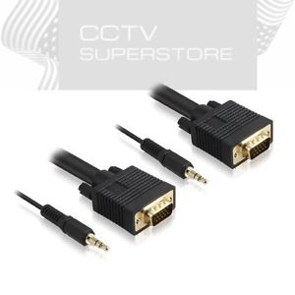

| **Item price** | $6.11 |
| --- | --- |
| **Quantity** | 1 |
| **Item number** | 121428275890 |
| **Shipping service** | Economy Shipping |

----------------------------------------------

| ORDER DATE  Oct 23, 2014 | ORDER TOTAL  US $32.69  Free shipping  [Leave feedback](http://feedback.ebay.com/ws/eBayISAPI.dll?LeaveFeedbackShow&useridto=legend973&transactID=1082680563019&item=291239265150&_trksid=p2060778.m2749.l2665)[View order details](http://payments.ebay.com/ws/eBayISAPI.dll?ViewPaymentStatus&transId=1082680563019&itemid=291239265150&_trksid=p2060778.m2749.l2673)  [More actions](http://www.ebay.com/mbf/Summary?MyEbay&gbh=1#) |
| --- | --- |

1 item sold by[legend973](http://www.ebay.com/usr/legend973?_trksid=p2060778.m2749.l2754)

| [DBPOWER P2P Wireless Wifi IP Camera Audio Video Wifi Camera IR Motion Detction](http://www.ebay.com/usr/legend973?_trksid=p2060778.m2749.l2754)  [DBPOWER P2P Wireless Wifi IP Camera Audio Video Wifi Camera IR Motion Detction](http://www.ebay.com/itm/291239265150?_trksid=p2060778.m2749.l2649&ssPageName=STRK%3AMEBIDX%3AIT)  ( 291239265150 )  Estimated delivery **Mon, Oct 27 - Fri, Oct 31**  Add note | ITEM PRICE:  US $32.69 |
| --- | --- |

## Item specifics

| Condition: | New: A brand-new, unused, unopened, undamaged item in its original packaging (where packaging is ... Read more | Type: | Box/Body |
| --- | --- | --- | --- |
| Color Mode: | Color | Connectivity: | IP/Network - Wireless |

Setup for Sending Alarm to Cell Phone. qq.com sends msg to cell phone.

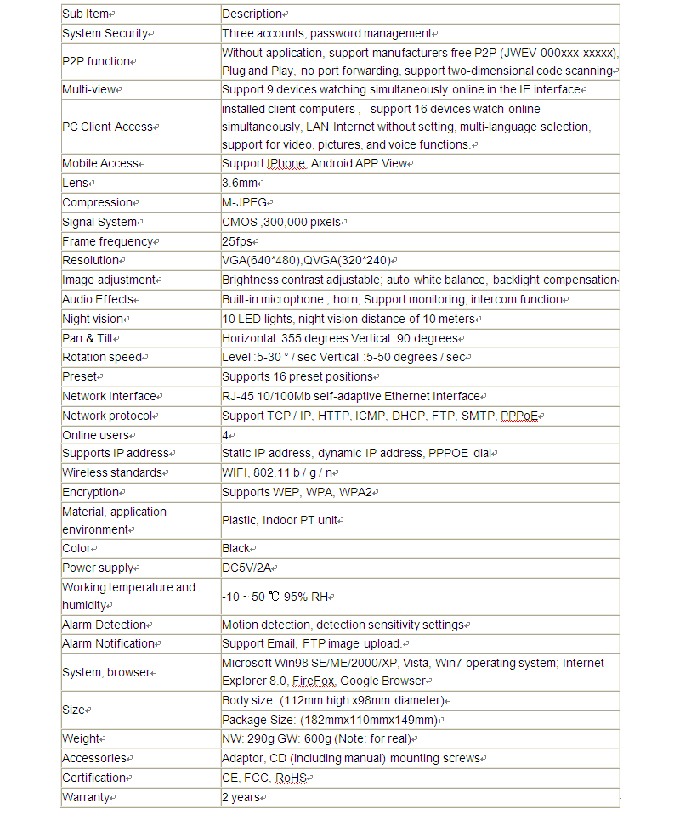

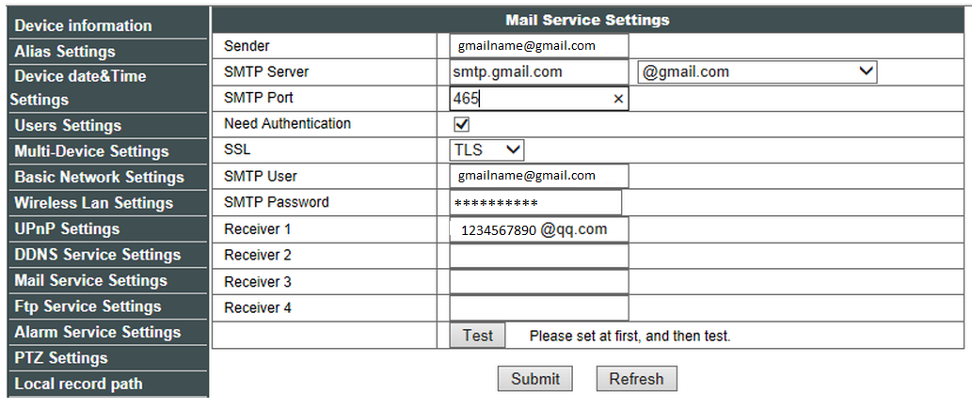

----------------------------------------------

| ORDER DATE  Oct 04, 2014 | ORDER TOTAL  US $1.98  Free shipping  [Leave feedback](http://feedback.ebay.com/ws/eBayISAPI.dll?LeaveFeedbackShow&useridto=hkiron-my&transactID=1278942305001&item=111469633756&_trksid=p2060778.m2749.l2665)[View order details](http://payments.ebay.com/ws/eBayISAPI.dll?ViewPaymentStatus&transId=1278942305001&itemid=111469633756&_trksid=p2060778.m2749.l2673)  [More actions](http://www.ebay.com/mbf/Summary?MyEbay&gbh=1#) |
| --- | --- |

1 item sold by[hkiron-my](http://www.ebay.com/usr/hkiron-my?_trksid=p2060778.m2749.l2754)

| [IIC/I2C/TWI/SPI Serial Interface Board Module Port for Arduino 1602LCD Display](http://www.ebay.com/usr/hkiron-my?_trksid=p2060778.m2749.l2754)  [IIC/I2C/TWI/SPI Serial Interface Board Module Port for Arduino 1602LCD Display](http://www.ebay.com/itm/111469633756?_trksid=p2060778.m2749.l2649&ssPageName=STRK%3AMEBIDX%3AIT)  ( 111469633756 )  Quantity: 2  Estimated delivery **Wed, Oct 22 - Wed, Nov 26**  Add note | ITEM PRICE:  US $1.98 |
| --- | --- |

----------------------------------------------

[20141021 - 4 CH 315M RF Wireless Remote Control Controller w/case](https://docs.google.com/document/d/1yazWHUxNTiDNa5EbFpAAzvVCRXVXxA5tq1-E5q3PHjE/edit?usp=sharing)

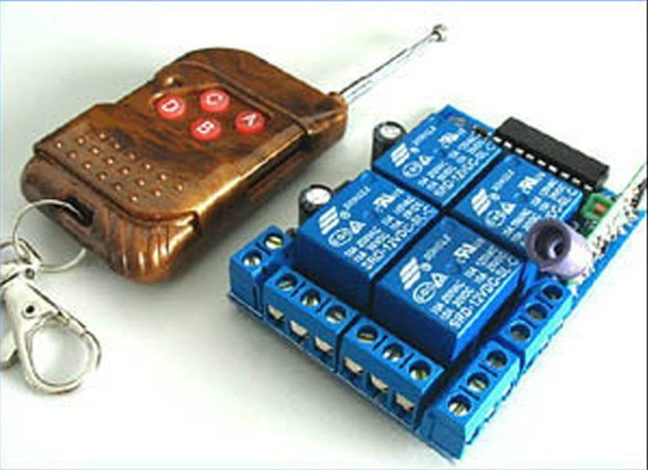

|  |
| --- |

----------------------------------------------

[**20141006 IO EXPANDER - MCP23017 Output Using -Works**](https://docs.google.com/document/d/1-5trSgdZSN60wVMjy7y8FHyw8jCoias9429GlU1QdHo/edit?usp=sharing)

# 

# **1 x MCP23017 16-Bit I/O Expander with I2C Interface IC 1 x MCP23017 16-Bit I/O Expander with I2C Interface IC - Manufacturer: Microchip Manufacturer Part No: MCP23017 Package / Case: PDIP-28 RoHS: Yes Datasheet: [Click Here](http://www.taydaelectronics.com/datasheets/A-897.pdf)**

----------------------------------------------**1**

**--------------------------------------------------------------------**

[Heart Beat Monitor Ebay](http://www.ebay.com/itm/Hot-Sales-NEW-KY-039-Finger-Measuring-Heartbeat-Sensor-Module-For-Arduino-RY-/201079897765?pt=LH_DefaultDomain_0&hash=item2ed14bbea5)

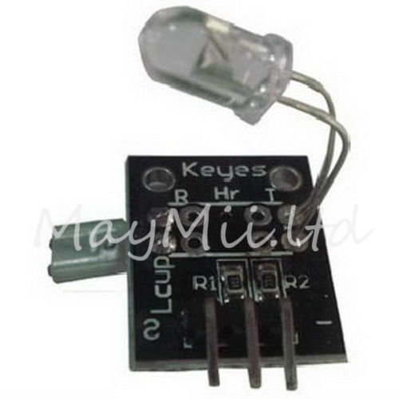

----------------------vvvvvvv Use this display with real time clock (next item) vvvv-------------------------

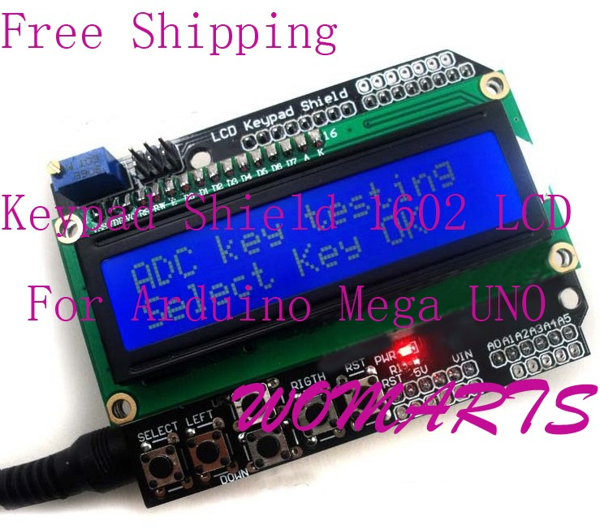

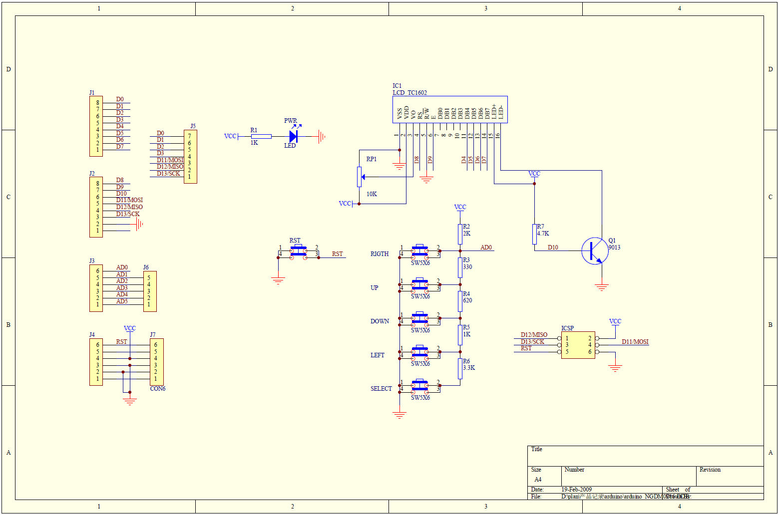

**Keypad Shield 1602 LCD For Arduino MEGA 2560 1280 UNO R3 A005**

[**http://www.ebay.com/itm/261039184894?ssPageName=STRK:MEWNX:IT&_trksid=p3984.m1497.l2649**](http://www.ebay.com/itm/261039184894?ssPageName=STRK:MEWNX:IT&_trksid=p3984.m1497.l2649)

**Problem with this shield (plugged in wrong?)**

[**http://forum.arduino.cc/index.php/topic,95618.0.html**](http://forum.arduino.cc/index.php/topic,95618.0.html)

**Use this with the real time clock?**

[**Link to real time clock project**](http://6502cpu.blogspot.com/2013/01/arduino-uno-and-ds1307-real-time-clock.html)

# **Feature:**

* **This is a 16x2 LCD Keypad module for Arduino Diecimila Duemilanove, UNO, MEGA1280, MEGA2560 board.**
* **Blue Backlight with white words, adjustable backlighting.**
* **4 Bit Arduino LCD Library**
* **100% brand new and high quality**

**Sample code:**

**/\***

**The circuit:**

**\* LCD RS pin to digital pin 8**

**\* LCD Enable pin to digital pin 9**

**\* LCD D4 pin to digital pin 4**

**\* LCD D5 pin to digital pin 5**

**\* LCD D6 pin to digital pin 6**

**\* LCD D7 pin to digital pin 7**

**\* LCD BL pin to digital pin 10**

**\* KEY pin to analogl pin 0**

**\*/**

**#include <LiquidCrystal.h>**

**LiquidCrystal lcd(8, 13, 9, 4, 5, 6, 7);**

**char msgs[5][16] = {"Right Key OK ",**

**"Up Key OK ",**

**"Down Key OK ",**

**"Left Key OK ",**

**"Select Key OK" };**

**int adc_key_val[5] ={50, 200, 400, 600, 800 };**

**int NUM_KEYS = 5;**

**int adc_key_in;**

**int key=-1;**

**int oldkey=-1;**

**void setup()**

**{**

**lcd.clear();**

**lcd.begin(16, 2);**

**lcd.setCursor(0,0);**

**lcd.print("ADC key testing");**

**}**

**void loop()**

**{**

**adc_key_in = analogRead(0); // read the value from the sensor**

**key = get_key(adc_key_in); // convert into key press**

**if (key != oldkey) // if keypress is detected**

**{**

**delay(50); // wait for debounce time**

**adc_key_in = analogRead(0); // read the value from the sensor**

**key = get_key(adc_key_in); // convert into key press**

**if (key != oldkey)**

**{**

**lcd.setCursor(0, 1);**

**oldkey = key;**

**if (key >=0){**

**lcd.print(msgs[key]);**

**}**

**}**

**}**

**delay(100);**

**}**

**// Convert ADC value to key number**

**int get_key(unsigned int input)**

**{**

**int k;**

**for (k = 0; k < NUM_KEYS; k++)**

**{**

**if (input < adc_key_val[k])**

**{**

**return k;**

**}**

**}**

**if (k >= NUM_KEYS)k = -1; // No valid key pressed**

**return k;**

**}**

----------------------------------------------------------------------------------------------------------------------------------

20140603 Arduino Uno and DS1307 real time clock

Instructions for assemply:[Arduino Uno and DS1307 real time clock.](http://6502cpu.blogspot.com/2013/01/arduino-uno-and-ds1307-real-time-clock.html)with display (text below).

Parts on Order:

[New I2C RTC DS1307 AT24C32 Real Time Clock Module For Arduino AVR 51 ARM PIC SMD](http://www.ebay.com/itm/New-I2C-RTC-DS1307-AT24C32-Real-Time-Clock-Module-For-Arduino-AVR-51-ARM-PIC-SMD-/360740357519?pt=LH_DefaultDomain_0&hash=item53fdcd058f)

[Keypad Shield 1602 LCD For Arduino MEGA 2560 1280 UNO R3 A005](http://www.ebay.com/itm/261039184894?ssPageName=STRK:MEWNX:IT&_trksid=p3984.m1439.l2649)

### Arduino Uno and DS1307 real time clock.

## 

I must admit the Arduino stuff pulled me in recently and distracted me from my main project that I want to finish a.s.a.p. - the MKHBC-8-R1 home-brew computer. But I am only a nerdy human. I could not help myself.

Here I'd like share with hobbyists community a simple project that can be used as a base to learn Arduino programming - the electronic clock with RTC (Real Time Clock) module and LCD/keypad shield.

Hardware:

1) [MINI Arduino I2C RTC DS1307 AT24C32 module.](http://www.ebay.com/itm/121021595460?ssPageName=STRK:MEWNX:IT&_trksid=p3984.m1439.l2648)

eBay item# 180646747674 by seller: e_goto

Serial: SKU 00100-049

2) [Keypad Shield 1602 LCD For Arduino MEGA 2560 1280 UNO R3 A005](http://www.ebay.com/itm/261039184894?ssPageName=STRK:MEWNX:IT&_trksid=p3984.m1439.l2649)

eBay item# 261039184894 by seller: womarts

The LCD/keypad shield you just put on top of the Arduino Uno compatible board. The RTC module is connected as outlined below:

RTC module -> Arduino Uno

SCL -> A5

SDA -> A4

VCC -> A3

GND -> A2

Note: the power to RTC (i2c_ds1307_at24c32) module is provided via Arduino's A2, A3 pins. The program code ensures proper logic levels/polarity on these pins so the RTC module gets the power through them.

Keypad functions:

SELECT - Switch between Clock Set/Clock Run modes. Select the date/time

parameter to setup in the Clock Set mode.

LEFT - Immediately exit Clock Set mode and set the clock.

UP/DOWN - Increment/decrement selected date/time parameter.

The code:

/*

* Date and time functions using a DS1307 RTC connected via I2C

* and Wire lib

* It is a simple clock application.

* Author: Marek Karcz 2013. All rights reserved.

* License: Freeware.

* Disclaimer: Use at your own risk.

* Hardware:

* 1) MINI Arduino I2C RTC DS1307 AT24C32 module.

* eBay item# 180646747674 by seller: e_goto

* Serial: SKU 00100-049

* 2) Keypad Shield 1602 LCD For Arduino MEGA 2560 1280 UNO

* R3 A005

* eBay item# 261039184894 by seller: womarts

*/

/*

The LCD circuit:

* LCD RS pin to digital pin 8

* LCD Enable pin to digital pin 9

* LCD D4 pin to digital pin 4

* LCD D5 pin to digital pin 5

* LCD D6 pin to digital pin 6

* LCD D7 pin to digital pin 7

* LCD BL pin to digital pin 10

* KEY pin to analog pin 0

*/

#include <Wire.h>

#include "RTClib.h"

#include <LiquidCrystal.h>

#define LOOP_DELAY 2000

LiquidCrystal lcd(8, 13, 9, 4, 5, 6, 7);

RTC_DS1307 RTC;

boolean bBlink = true;

const char *appVer = "MKHBC RTC 1.3 ";

const char *modTxt = "Set clock ... ";

// Global variables for time setup/displaying purposes.

uint16_t set_Year;

uint8_t set_Month;

uint8_t set_Day;

uint8_t set_Hour;

uint8_t set_Minute;

/*

* Keypad shield uses resistors array and single analog input.

* The values in adc_key_val array help to determine which

* key on the shield was pressed by checking the analog input

* read value.

*/

const int adc_key_val[5] ={50, 200, 400, 600, 800 };

int adc_key_in;

// keypad keys definitions

enum KP

{

KEY_RIGHT = 0,

KEY_UP,

KEY_DOWN,

KEY_LEFT,

KEY_SELECT,

KEY_NUMKEYS, // mark the end of key definitions

KEY_NONE // definition of none of the keys pressed

};

// Finite Machine States

enum FMS

{

RUN = 0,

SETCLOCK,

SETYEAR,

SETMONTH,

SETDAY,

SETHOUR,

SETMINUTE

} ClockState;

// Finite Machine State Transitions Table.

// Defines the flow of the application modes from one to another.

enum FMS StateMachine[] =

{

/* RUN -> */ SETCLOCK,

/* SETCLOCK -> */ SETYEAR,

/* SETYEAR -> */ SETMONTH,

/* SETMONTH -> */ SETDAY,

/* SETDAY -> */ SETHOUR,

/* SETHOUR -> */ SETMINUTE,

/* SETMINUTE -> */ RUN

};

---------------------------------------------------------------------------------------------------------------------------------

20140603B **Rotary Encoder Module Brick Sensor**

**New 1pc KY-040 Rotary Encoder Module Brick Sensor Development For Arduino**

[New 1pc KY-040 Rotary Encoder Module Brick Sensor Development For Arduino](http://www.ebay.com/itm/New-1pc-KY-040-Rotary-Encoder-Module-Brick-Sensor-Development-For-Arduino-/400621395765?pt=LH_DefaultDomain_0&hash=item5d46e55f35)

Instructions (text below) [Reading rotary encoder on Arduino](https://www.circuitsathome.com/mcu/reading-rotary-encoder-on-arduino)

| [TC74A0 5.0VAT Serial Digital Temperature Sensor I2C](http://www.ebay.com/itm/1PCS-TC74A0-5-0VAT-Serial-Digital-Temperature-Sensor-for-Arduino-USA-/261527595375?pt=LH_DefaultDomain_0&hash=item3ce442696f)  in stock. usd for Jeremy Blums episode 7 <http://www.ebay.com/itm/1PCS-TC74A0-5-0VAT-Serial-Digital-Temperature-Sensor-for-Arduino-USA-/261527595375?pt=LH_DefaultDomain_0&hash=item3ce442696f> |
| --- |

# Reading rotary encoder on Arduino

**By Oleg Mazurov**

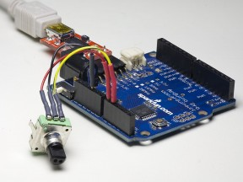

Rotary encoder connected to Arduino

Quadrature rotary encoders, also known as rotary pulse generators, are popular input devices for embedded platforms, including Arduino. Several rotary encoder code examples are posted on Arduino site and elsewhere, however, they treat encoder as a pair of switches, adding decoding/debouncing overhead. For many years, I used an algorithm based on the fact that quadrature encoder is a [Gray code](http://en.wikipedia.org/wiki/Gray_code) generator and if treated as such, can be read reliably in 3 straight step without need for debouncing. As a result, the code I’m using is very fast and simple, works very well with cheap low-quality encoders, but is somewhat cryptic and difficult to understand. Soon after posting [one of my projects](http://www.circuitsathome.com/mcu/programming/vigorius-stirring-redefined-part-2-electronics) where I used rotary encoder to set motor speed i started receiving e-mails asking to explain the code. This article is a summary of my replies – I’m presenting small example written for the purpose of illustrating my method. I’m also going through the code highlighting important parts.

The hardware setup can be seen on title picture. The [encoder from Sparkfun](http://www.sparkfun.com/commerce/product_info.php?products_id=9117) is connected to a vintage Atmega168-based Arduino Pro. Common pin of the encoder is connected to ground, pins A and B are connected to pins 14 and 15, AKA Analog pins 0 and 1, configured as digital inputs. We also need a serial connection to the PC to receive power, program the Arduino, and send program output to the terminal. For this purpose, Sparkfun [FTDI basic breakout](http://www.sparkfun.com/commerce/product_info.php?products_id=8772) is used.

Connecting encoder pins to pins 0 and 1 of 8-bit MCU port makes encoder reading code very simple. If analog pins are needed for something else, it is possible to move encoder to digital pins 8,9 or 0,1 (losing serial port) with no modification of code logic. While technically using any two consecutive port pins is possible with a bit of tweaking, using non-consecutive pins for encoder input with this method is not recommended. Lastly, it sometimes hard to determine which encoder pin is A and which is B; it is easier to connect them at random and if direction is wrong, swap the pins.

Example code is posted below. It is complete sketch – you can copy it from this page and paste into Arduino IDE window, compile, upload and run. The result of rotating the encoder can be seen in terminal window. Note that serial speed in the sketch is set to 115200, you will need to set your PC terminal to that speed as well. The explanation of the code is given after the listing.

| 1 2 3 4 5 6 7 8 9 10 11 12 13 14 15 16 17 18 19 20 21 22 23 24 25 26 27 28 29 30 31 32 33 34 35 36 37 38 39 | */* Rotary encoder read example */* #define ENC_A 14 #define ENC_B 15 #define ENC_PORT PINC   void setup() {  */* Setup encoder pins as inputs */*  pinMode(ENC_A, INPUT);  digitalWrite(ENC_A, HIGH);  pinMode(ENC_B, INPUT);  digitalWrite(ENC_B, HIGH);  Serial.begin (115200);  Serial.println("Start"); }   void loop() {  static uint8_t counter = 0; *//this variable will be changed by encoder input*  int8_t tmpdata;  */**/*  tmpdata = read_encoder();  if( tmpdata ) {  Serial.print("Counter value: ");  Serial.println(counter, DEC);  counter += tmpdata;  } }   */* returns change in encoder state (-1,0,1) */* int8_t read_encoder() {  static int8_t enc_states[] = {0,-1,1,0,1,0,0,-1,-1,0,0,1,0,1,-1,0};  static uint8_t old_AB = 0;  */**/*  old_AB <<= 2; *//remember previous state*  old_AB |= ( ENC_PORT & 0x03 ); *//add current state*  return ( enc_states[( old_AB & 0x0f )]); } |
| --- | --- |

First three **#defines** set names for port pins. This way, if you want to use different pins for your encoder, you can do it here without sifting through code looking for pin names. If you’d like to move encoder pins to Arduino pins 8 and 9, ENC_PORT shall be defined as PINB, and for pins 0,1 as PIND.

In **setup()** function hardware is initialized. **pinMode** sets the pin as input so we can read it and **digitalWrite** turns on pull-up resistor on the pin so it won’t dangle in the air when switch is open. Finally, the serial port is initialized and message is printed as an indicator that port is working – if you can’t see “Start” on your terminal screen, check PC port settings.

Let’s go down to line 30, where **read_encoder()** function starts. **enc_states[]** array is a look-up table; it is pre-filled with encoder states, with “-1″ or “1″ being valid states and “0″ being invalid. We know that there can be only two valid combination of previous and current readings of the encoder – one for the step in a clockwise direction, another one for counterclockwise. Anything else, whether it’s encoder that didn’t move between reads or an incorrect combination due to switch bouncing, is reported as zero.

Note that **old_AB** is declared static. This means that it’s value will be retained between function calls therefore previous encoder reading will be preserved. When function is called, **old_AB** gets shifted left two times (line 36) saving previous reading and setting two lower bits to “0″ so the current reading can be correctly [ORed](http://en.wikipedia.org/wiki/Logical_disjunction) here. Then **ENC_PORT & 0×03** reads the port to which encoder is connected and sets all but two lower bits to zero so when you OR it with old_AB bits 2-7 would stay intact. Then it gets ORed with old_AB (line 37, **old_AB |= ( ENC_PORT & 0×03 )**). At this point, we have previous reading of encoder pins in bits 2,3 of old_AB, current readings in bits 0,1, and together they form index of (AKA pointer to) enc_states[] array element containing current state – either increment, decrement, or no change. All that is left to do is return this state to the calling function, and line 38 does just that. Upper half of old_AB gets zeroed by**old_AB & 0x0f** – if we don’t do this, we will be reading memory past enc_states[] array.

The above paragraph was pretty long explanation for mere 5 lines of code (counting two declarations); if you are reading this, 98% of work is done. The rest of the code is very easy. We are now moving up to line 17, where **loop()** function is residing. **counter** variable is the one which is modified by encoder and **tmpdata** is used to hold the reading. On line 22, encoder is read. If encoder state has changed, i.e.,**read_encoder()** returned non-zero, current value of **counter** variable is printed and then **counter** is updated with **tmpdata**. This is done within conditional statement on lines 22-27. The loop then ends and starts again.

Now let’s briefly talk about real-life applications of this method. If you’re using Sparkfun encoder, you’ll notice that it gives 4 increments per click and it’s impossible to make it hold position between clicks. Therefore, to count clicks you will need to divide **counter** variable by 4. Also, if counter larger than 255 is necessary, the declaration for it would have to be changed to **uint16_t** or longer. Another nice modification, left out to keep code simple, would be to move enc_states[] array to program memory using PROGMEM type saving several bytes of precious RAM.

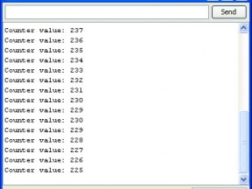

Rotary encoder singing out of tune

In order for this method to work well, **read_encoder()** function needs to be called fairly often . To see what happens when loop is slow, lower serial port speed – go to line 13, change “115200″ to “9600″, recompile the sketch and run (don’t forget to reconfigure the terminal on PC side). Picture on the left shows the result. Note that encoder goes down from 237 to 229, then jumps up to 230, then continues going down. Sometimes it counts correctly but gives 2 or 3 states per click instead of 4. Instabilities like this are good indication of slow loop. If encoder is used to things like setting motor speed or sound volume, this behavior won’t do much harm because encoder will never skip back more than one state and overall counting would still be in the right direction. However, if encoder is used for interfacing with display, glitches like that are very annoying. Therefore, for user interface applications, loop time should be kept short and in some cases it may be even necessary to convert encoder reading function into interrupt service routine. Given the size and speed of encoder read function, such conversion can be done without much difficulty.

To summarize: I presented a method to convert quadrature rotary encoder output into direction information using look-up table. The method makes debouncing unnecessary, and as a result, conversion function implemented with this method is very short, fast, and works very well on small 8-bit MCU platforms, such as Arduino.

---------------------------------------------------------------------------------------------------------------------------------

20140603d [5V 1-Channel Relay Expansion Board Module Low Level Triger for Arduino AVR PIC](http://www.ebay.com/itm/5V-1-Channel-Relay-Expansion-Board-Module-Low-Level-Triger-for-Arduino-AVR-PIC-/221277557378?pt=LH_DefaultDomain_0&hash=item33852b9282)

[5V 1-Channel Relay Expansion Board Module Low Level Triger for Arduino AVR PIC](http://www.ebay.com/itm/5V-1-Channel-Relay-Expansion-Board-Module-Low-Level-Triger-for-Arduino-AVR-PIC-/221277557378?pt=LH_DefaultDomain_0&hash=item33852b9282)

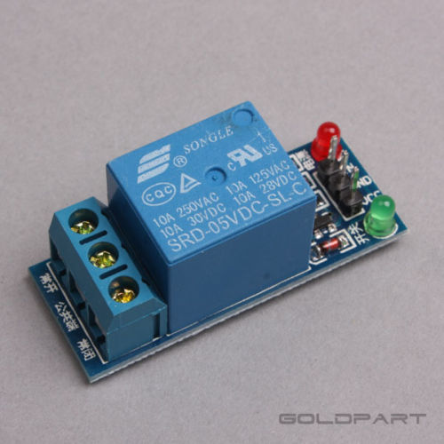

---------------------------------------------------------------------------------------------------------------------------------

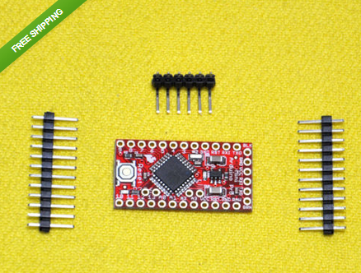

Order:[New Mini ATMEAG328 3.3V 8Mhz Replace ATmega128 For Arduino Pro Mini](http://www.ebay.com/itm/New-Mini-ATMEAG328-3-3V-8Mhz-Replace-ATmega128-For-Arduino-Pro-Mini-Compatible-/191182699659?pt=LH_DefaultDomain_0&hash=item2c83607c8b)

[Compatible](http://www.ebay.com/itm/New-Mini-ATMEAG328-3-3V-8Mhz-Replace-ATmega128-For-Arduino-Pro-Mini-Compatible-/191182699659?pt=LH_DefaultDomain_0&hash=item2c83607c8b)

It's RED!

It's thin (0.8mm)!This is a 3.3V running the 8MHz bootloader (select 'Duemilanove w/ 328' within the software). Pro Mini does not

come with connectors populated so that you can solder in any connector or wire with any orientation you need.The Arduino Pro

series is meant for users that understand the limitations of system voltage (3.3V), lack of connectors, and USB off board.

We used all SMD components, made it two layer, etc. This board connects directly to the FTDI Basic Breakout board and supports

auto-reset. The Pro Mini also works with the FTDI cable but the FTDI cable does not bring out the DTR pin so the auto-reset

feature will not work.

Features:

ATmega328 running at 8MHz with external resonator (0.5% tolerance)

Low-voltage board needs no interfacing circuitry to popular 3.3V devices and modules (GPS, accelerometers, sensors, etc)

USB connection off board

Supports auto-reset

3.3V regulator

Max 150mA output

Over current protected

Reverse polarity protected

DC input 3.3V up to 12V

On board Power and Status LEDs

Dimensions: 0.7x1.3" (18x33mm)

Packing List:

1 x Pro Mini Atmega328P board

2 x 12Pin Header

1 x 6Pin Left Header

---------------------------------------------------------------------------------------------------------------------------------

20140603e

[1pc 5V-12V NE555 Frequency Adjustable Pulse Generator Module For Arduino New](http://www.ebay.com/itm/1pc-5V-12V-NE555-Frequency-Adjustable-Pulse-Generator-Module-For-Arduino-New-/251538343857?pt=LH_DefaultDomain_2&hash=item3a90da87b1)

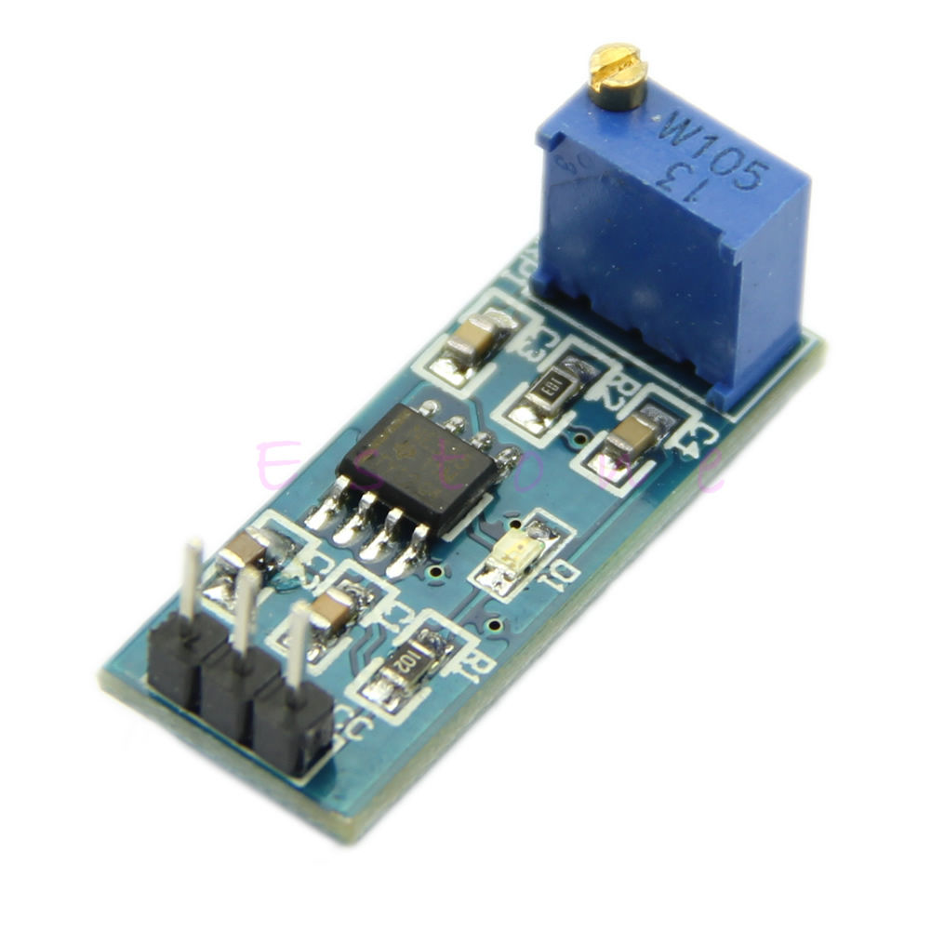

* **100% brand new and high quality.**
* Quantity: 1pc
* Color: as picture show
* Size: 28mm x 11mm x 12mm/1.09" x 0.43" x 0.47" (inch) (approx)
* **Specifications:**
* 1. Onboard NE555 IC.
* 2. Single channel signal output, the output duty cycle about 50% square wave.
* 3. Plate load resistor, adjust the resistance to control the output frequency.
* 4. Onboard power indicator.
* 5. Working voltage: 5V~12V.
* Schematic Diagram

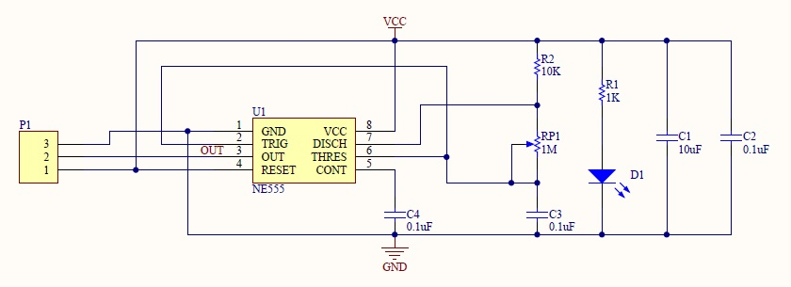

* If you need file, please click this button below.

**Download**

---------------------------------------------------------------------------------------------------------------------------------

20140603c **IRP Sensor Human Body detecting module Pyroelectric HC-SR501 For Arduino MCU MA**

* **Infrared sensor with control circuit board**
* **The sensitivity and holding time can be adjusted**
* **Working Voltage Range: DC 5V- 20V**
* **Current drain:<60uA**
* **Voltage Output: High 3.3 V /Low 0V**
* **Detection distance: ≤7M**
* **Detection range: <120°**
* **Delay time: 5-200S(can be adjusted)**
* **Blockade time: 2.5 S (default)**
* **Trigger: L: unrepeatable trigger, H: Repeat Trigger (default)**
* **Work temperature:-15 ~ 70°C**
* **Dimension: 3.2cm x 2.4cm (Lx W) (approx)**
* **Applications:**
* **1. Security Products**
* **2. the human body sensors toys**
* **3. the human body sensor lighting**
* **4. industrial automation and control, etc.**
* **It can automatically and quickly open various types of incandescent, fluorescent lamps, buzzer, automatic doors, electric fans, automatic washing machine and dryer**
* **Machines and other devices, is a high-tech products. Especially suitable for enterprises, hotels, shopping malls, warehouses and family aisles, corridors and other sensitive**
* **Sense of region, or for the security zone automatic lighting, lighting and alarm systems.**
* **Note:**
* **The potentiometer clockwise to adjust the distance, sensing range increases (about 7 meters), on the contrary, sensing range decreases (about 3 meters).**
* **Delay adjustment potentiometer clockwise rotation, sensor delay longer (about 300S), the other hand, induction by the short delay (about 5S).**

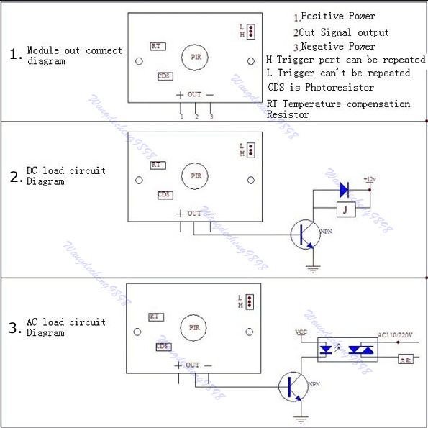

Instructions: [PIR Sensor (Part 2)](http://arduinobasics.blogspot.com/search/label/HC-SR501)

Item on Order:[PIR Sensor Human Body detecting module Pyroelectric HC-SR501 For Arduino MCU MA](http://www.ebay.com/itm/PIR-Sensor-Human-Body-detecting-module-Pyroelectric-HC-SR501-For-Arduino-MCU-MA-/121317513334?pt=LH_DefaultDomain_0&hash=item1c3f165876)

| SKU: A876 |
| --- |
| | **Description** | | --- | | **Electrical parameters:**  Product Type: HC--SR501 Body Sensor Module  Operating voltage range: DC 4.5-20V  Quiescent Current: <50uA  Level output: High 3.3 V /Low 0V  Trigger: L can not be repeated trigger/H can be repeated trigger(Default repeated trigger)  Delay time: 5-200S(adjustable) the range is (0.xx second to tens of second)  Block time: 2.5S(default)Can be made a range(0.xx to tens of seconds  Board Dimensions: 32mm*24mm  Angle Sensor: <100 ° cone angle  Operation Temp: -15-+70 degrees  Lens size sensor: Diameter:23mm(Default)    **There is not H/L jumper included in this revision.**  **Features:**  1, the automatic sensor: to enter the sensor output range is high, people leave the sensor range of the automatic  delay off high, output low.  2,the photosensitive control (optional, factory is not set) may set the photosensitive control during the day or  light intensity without induction.  3, the temperature compensation (optional, factory is not set): In the summer when the ambient temperature rises  to 30 ~ 32 ℃, slightly shorter detection range, temperature compensation can be used as a performance compensation.  4, two trigger mode: (can be selected by jumpers)  a, can not repeat the trigger: the sensor output high, the delay time is over, the output will automatically become low from high;  b, repeatable trigger: the sensor output high after the delay period, if the human body in its sensing range activities, its output will remain high until after the delay will be left high to low (sensor module review Measured activities of each body will be automatically extended after a delay time, and the final event of the delay time Starting point of time)  5, with induction blocking time (the default setting: 2.5S block time): sensor module, after each sensor output (high change Into a low level), you can set up a blockade followed by time period, in this time period the sensor does not accept any sensor signal. This feature can have a "sensor output time" and "blocking time" the interval  between the work produced can be applied to detect the interval Products; also inhibit this function during load switching for a variety of interference. (This time can be set at zero seconds - Tens of seconds).  6, the working voltage range: the default voltage DC4.5V-20V.  7, micro-power consumption: static current "50 microamps, especially for battery-powered automatic control products.  8, the output high level signals: types of circuits can be easily and docking.  **Instructions:**  1. Sensing module for about a minute after power initialization time, during the interval to the output module 0-3 times a minute in standby mode.  2. Should avoid direct lighting such as interference sources close the surface of the lens module so as to avoid the introduction of interference signal generator malfunction; use of the environment to avoid the flow of the wind, the wind sensor will also cause interference.  3. Sensor module using a dual probe, the probe's window is rectangular, dual (A per B million) in the direction of the ends of long, when the body passed from left to right or right to left when the reach the dual IR time, distance difference, the greater the difference, more sensitive sensors, when the body from the front to the probe or from top to bottom or from bottom to top direction passing, dual IR not detected changes in the distance, no difference value, the sensor insensitive or does not work; so the sensors should be installed dual direction of the probe with human activities as much as possible parallel to the direction of maximum to ensure that the body has been passed by the dual sensor probe. To increase the sensing range of angles, the module using a circular lens, the probe also makes sense on all four sides, but still higher than the upper and lower left and right direction of sensing range, sensitivity and strong, still as far as possible by the above installation requirements. VCC, trig (control side), echo (receiving end), GND  4. Dimensions and Adjustment:  Note: The potentiometer clockwise to adjust the distance, sensing range increases (about 7 meters), on the contrary, sensing range decreases (about 3 meters). Delay adjustment potentiometer clockwise rotation, sensor delay longer (about 300S), the other hand, induction by the short delay (about 5S).  5. Applications  a, Security Products  b, the human body sensors toys  c, the human body sensor lighting  d, industrial automation and control, etc.  It can automatically and quickly open various types of incandescent, fluorescent lamps, buzzer, automatic doors, electric fans, automatic washing machine and dryer Machines and other devices, is a hightech products. Especially suitable for enterprises, hotels, shopping malls, warehouses and family aisles, corridors and other sensitive Sense of region, or for the security zone automatic lighting, lighting and alarm systems.  **Package Contents:**  ●1x sensor | |

Instructions:



#### **Sketch**

#### 

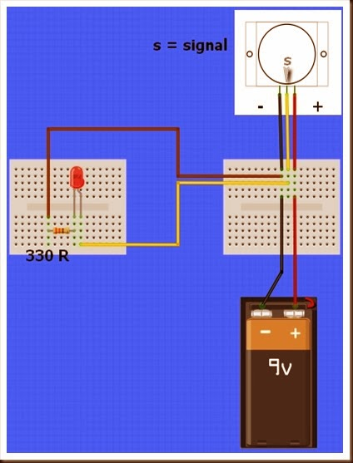

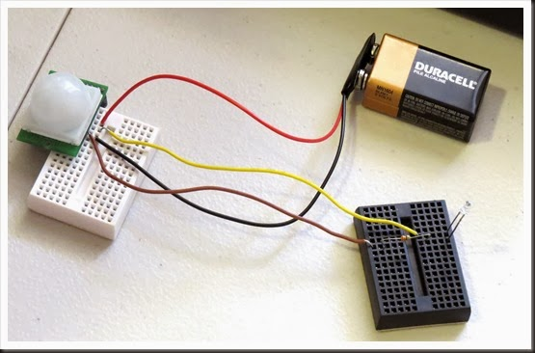

### [PIR Sensor (Part 2)](http://arduinobasics.blogspot.com/2013/12/pir-sensor-part-2.html)

**[](http://arduinobasics.blogspot.com/2013/12/pir-sensor-part-2.html)**

In this tutorial we will connect our HC-SR501 PIR (movement) Sensor to an Arduino UNO. The PIR sensor will be powered by the Arduino and when movement is detected, the PIR sensor will send a signal to Digital Pin 2. The Arduino will respond to this signal by illuminating the LED attached to Pin 13.

[PIR Sensor (Part 1)](http://arduinobasics.blogspot.com.au/2013/12/pir-sensor-part-1.html) : Showed that this sensor can be used in isolation (without an Arduino). However, I will still demonstrate how you can attach this sensor to the Arduino so that we can move forward to more advanced objectives and concepts.

#### 

#### **[Video](https://www.youtube.com/watch?v=JrSduQNGv-w)**



#### 

#### **Parts Required**

* [Mini Breadboard 4.5cm x 3.5cm](http://www.epictinker.com/Mini-Breadboard-4-5cmx3-5cm-p/str122c2m.htm)
* [PIR Motion sensor (HC-SR501)](http://www.epictinker.com/PIR-Motion-Sensor-p/sen-1003.htm)
* [LED and 330ohm resistor](http://www.epictinker.com/Mixed-Color-and-Size-LED-Kit-p/led-1001.htm)
* [Breadboard Jumper Wire](http://www.epictinker.com/Solderless-Breadboard-Jumper-Wire-Kit-p/cab-1008.htm)
* [Arduino UNO (or compatible board)](http://www.epictinker.com/Freetronics-Eleven-100-Arduino-Uno-Compatible-p/ard-1002.htm)

[](http://www.epictinker.com/Freetronics-Eleven-100-Arduino-Uno-Compatible-p/ard-1002.htm)

#### **Fritzing Sketch**

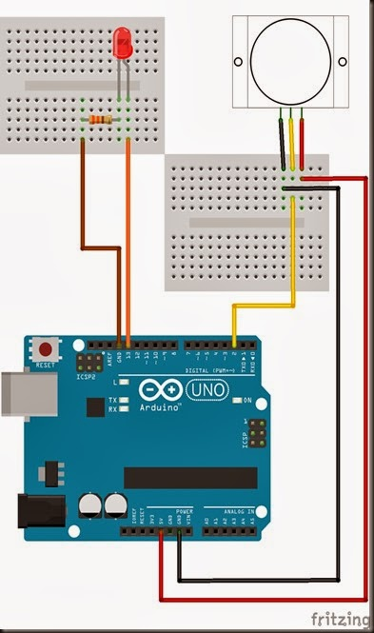



#### 

#### **Arduino Sketch**

| 1  2  3  4  5  6  7  8  9 10 11 12 13 14 | /*Simple PIR sketch: Written by ScottC, 19th Dec 2013  <http://arduinobasics.blogspot.com/>    ----------------------------------------------------*/  void **setup**(){  pinMode(13,OUTPUT);  pinMode(2,INPUT); }  void **loop**(){  digitalWrite(13,digitalRead(2)); } |
| --- | --- |

The sketch above reads the signal coming in from the PIR sensor on Pin 2, and if it reads HIGH, it light up the LED attached to Pin 13. If it reads LOW, it will turn the LED off. This is all controlled by line 13 in the Arduino Sketch above.

The following table helps to identify the purpose of the potentiometers on the PIR sensor. Most people say they use trial and error. I will attempt to reduce the mystery of these components on the PIR board.

| 104 (Left) – Max   |  | LED on = 20 sec  LED off = 3 sec | | --- | --- |   When you move the 104 labelled potentiometer all the way to the left (max position), the LED will remain on for 20 seconds after movement is detected. The 20 seconds is independent of the other potentiometer (105) setting. When the LED turns off, it will remain off for 3 seconds before the sensor will trigger again from any further movement. |
| --- | --- | --- |

| 104 (Right) – Min   |  | LED on = 1 sec  LED off = 3 sec | | --- | --- |   When you mov104 labelled potentiometer all the way to the right (min position), the LED will remain on for 1 second after movement is detected. When the LED turns off, it will remain off for 3 seconds before the sensor will trigger again from any further movement. |
| --- | --- | --- |

| 105 (Left) – Max   |  | Most sensitive – Detects movement from over 10 steps away. | | --- | --- |   The 105 labelled potentiometer controls the sensitivity of the PIR sensor. When in the left position, the PIR sensor is most sensitive and small amounts of movement will trigger the sensor. It detected my movement (ie a single step to the left of right) from over 10 steps away from the sensor. I was very impressed. |
| --- | --- | --- |

| 105 (Right) – Mina   |  | Least sensitive: Need significant movement for sensor to trigger. Detects movement from about 4 steps away. | | --- | --- |   When the 105 labelled potentiometer is twisted to the right, the PIR sensor becomes a lot less sensitive. I needed to take much bigger steps to the left or right to trigger the sensor (about 3 times the size compared to the left position). It also had a lot more trouble detecting movement occurring further away. It only really started to detect my movement when I was about 4 steps away from it. |
| --- | --- | --- |

My preferred combination was 104-Right (min) + 105-Left (max), which meant that the sensor would remain on for only a short period of time, and detect any subtle movements in the room.

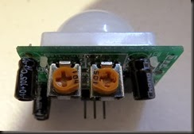

I have not tested to see how it performs over a very long period with this setting, and whether it would suffer from false positive readings, but that could easily be fixed by turning the 105 labelled potentiometer a bit more to the right.

Posted by Scott C at [23:30](http://arduinobasics.blogspot.com/2013/12/pir-sensor-part-2.html) [7 comments](http://arduinobasics.blogspot.com/2013/12/pir-sensor-part-2.html#comment-form)

[Email This](http://www.blogger.com/share-post.g?blogID=4060435813840662690&postID=2083407114662723900&target=email)[BlogThis!](http://www.blogger.com/share-post.g?blogID=4060435813840662690&postID=2083407114662723900&target=blog)[Share to Twitter](http://www.blogger.com/share-post.g?blogID=4060435813840662690&postID=2083407114662723900&target=twitter)[Share to Facebook](http://www.blogger.com/share-post.g?blogID=4060435813840662690&postID=2083407114662723900&target=facebook)[Share to Pinterest](http://www.blogger.com/share-post.g?blogID=4060435813840662690&postID=2083407114662723900&target=pinterest)

Labels: [Arduino](http://arduinobasics.blogspot.com/search/label/Arduino), [ArduinoBasics](http://arduinobasics.blogspot.com/search/label/ArduinoBasics), [HC-SR501](http://arduinobasics.blogspot.com/search/label/HC-SR501), [LED](http://arduinobasics.blogspot.com/search/label/LED), [movement](http://arduinobasics.blogspot.com/search/label/movement), [PIR](http://arduinobasics.blogspot.com/search/label/PIR), [Sensor](http://arduinobasics.blogspot.com/search/label/Sensor), [tutorial](http://arduinobasics.blogspot.com/search/label/tutorial)

16 December 2013

[PIR Sensor (Part 1)](http://arduinobasics.blogspot.com/2013/12/pir-sensor-part-1.html)

**[](http://arduinobasics.blogspot.com/2013/12/pir-sensor-part-1.html)**

PIR sensors are pyroelectric or “passive” infrared sensors which can be used to detect changes in infrared radiation levels. The sensor is split in half, and any significant difference in IR levels between the two sections of the sensor will cause the signal pin to swing HIGH or LOW. Hence it can be used as a motion detector when IR levels move across and trigger the sensor (eg. human movement across a room).

The potentiometers are used to adjust the amount of time the sensor remains “on” and “off” after being triggered. Essentially the delay between triggered events.

Here are a couple of pictures of the PIR sensor.

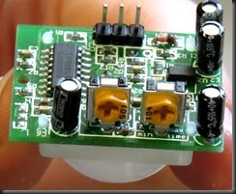 [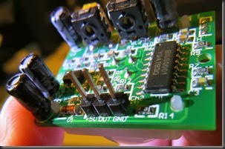](http://lh3.ggpht.com/-23h49dtAiSc/Uq8LtgqhRPI/AAAAAAAAAl8/_084NDYr5jE/s1600-h/IMG_0659%25255B2%25255D.jpg) [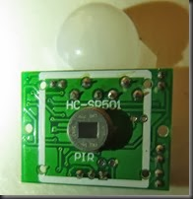](http://lh6.ggpht.com/-w6S_WsQqZSI/Uq8Ly6OvY2I/AAAAAAAAAms/w9rnU1d0k-Q/s1600-h/IMG_0658%25255B3%25255D.jpg)

----------------------------------------------------------------------------------------------

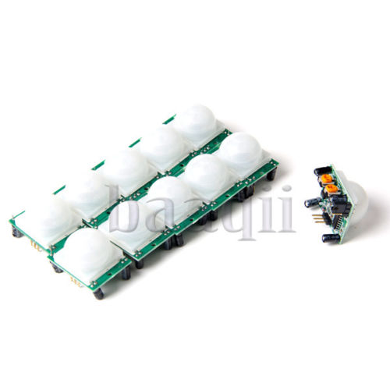

**PIR Sensor Human Body detecting module Pyroelectric HC-SR501 For Arduino MCU MA**

| **SKU: A876** |
| --- |
| | **Description** | | --- | | **Electrical parameters:**  **Product Type: HC--SR501 Body Sensor Module**  **Operating voltage range: DC 4.5-20V**  **Quiescent Current: <50uA**  **Level output: High 3.3 V /Low 0V**  **Trigger: L can not be repeated trigger/H can be repeated trigger(Default repeated trigger)**  **Delay time: 5-200S(adjustable) the range is (0.xx second to tens of second)**  **Block time: 2.5S(default)Can be made a range(0.xx to tens of seconds**  **Board Dimensions: 32mm*24mm**  **Angle Sensor: <100 ° cone angle**  **Operation Temp: -15-+70 degrees**  **Lens size sensor: Diameter:23mm(Default)**    **There is not H/L jumper included in this revision.**  **Features:**  **1, the automatic sensor: to enter the sensor output range is high, people leave the sensor range of the automatic**  **delay off high, output low.**  **2,the photosensitive control (optional, factory is not set) may set the photosensitive control during the day or**  **light intensity without induction.**  **3, the temperature compensation (optional, factory is not set): In the summer when the ambient temperature rises**  **to 30 ~ 32 ℃, slightly shorter detection range, temperature compensation can be used as a performance compensation.**  **4, two trigger mode: (can be selected by jumpers)**  **a, can not repeat the trigger: the sensor output high, the delay time is over, the output will automatically become low from high;**  **b, repeatable trigger: the sensor output high after the delay period, if the human body in its sensing range activities, its output will remain high until after the delay will be left high to low (sensor module review Measured activities of each body will be automatically extended after a delay time, and the final event of the delay time Starting point of time)**  **5, with induction blocking time (the default setting: 2.5S block time): sensor module, after each sensor output (high change Into a low level), you can set up a blockade followed by time period, in this time period the sensor does not accept any sensor signal. This feature can have a "sensor output time" and "blocking time" the interval**  **between the work produced can be applied to detect the interval Products; also inhibit this function during load switching for a variety of interference. (This time can be set at zero seconds - Tens of seconds).**  **6, the working voltage range: the default voltage DC4.5V-20V.**  **7, micro-power consumption: static current "50 microamps, especially for battery-powered automatic control products.**  **8, the output high level signals: types of circuits can be easily and docking.**  **Instructions:**  **1. Sensing module for about a minute after power initialization time, during the interval to the output module 0-3 times a minute in standby mode.**  **2. Should avoid direct lighting such as interference sources close the surface of the lens module so as to avoid the introduction of interference signal generator malfunction; use of the environment to avoid the flow of the wind, the wind sensor will also cause interference.**  **3. Sensor module using a dual probe, the probe's window is rectangular, dual (A per B million) in the direction of the ends of long, when the body passed from left to right or right to left when the reach the dual IR time, distance difference, the greater the difference, more sensitive sensors, when the body from the front to the probe or from top to bottom or from bottom to top direction passing, dual IR not detected changes in the distance, no difference value, the sensor insensitive or does not work; so the sensors should be installed dual direction of the probe with human activities as much as possible parallel to the direction of maximum to ensure that the body has been passed by the dual sensor probe. To increase the sensing range of angles, the module using a circular lens, the probe also makes sense on all four sides, but still higher than the upper and lower left and right direction of sensing range, sensitivity and strong, still as far as possible by the above installation requirements. VCC, trig (control side), echo (receiving end), GND**  **4. Dimensions and Adjustment:**  **Note: The potentiometer clockwise to adjust the distance, sensing range increases (about 7 meters), on the contrary, sensing range decreases (about 3 meters). Delay adjustment potentiometer clockwise rotation, sensor delay longer (about 300S), the other hand, induction by the short delay (about 5S).**  **5. Applications**  **a, Security Products**  **b, the human body sensors toys**  **c, the human body sensor lighting**  **d, industrial automation and control, etc.**  **It can automatically and quickly open various types of incandescent, fluorescent lamps, buzzer, automatic doors, electric fans, automatic washing machine and dryer Machines and other devices, is a hightech products. Especially suitable for enterprises, hotels, shopping malls, warehouses and family aisles, corridors and other sensitive Sense of region, or for the security zone automatic lighting, lighting and alarm systems.** | |

[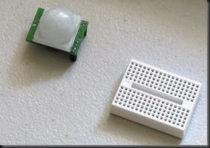](http://lh6.ggpht.com/-w6S_WsQqZSI/Uq8Ly6OvY2I/AAAAAAAAAms/w9rnU1d0k-Q/s1600-h/IMG_0658%25255B3%25255D.jpg)

The sensor used in this tutorial is HC-SR501 PIR sensor.

You can get more information about this sensor [here](http://www.ladyada.net/learn/sensors/pir.html).



#### **Parts Required**

* [Mini Breadboard 4.5cm x 3.5cm](http://www.epictinker.com/Mini-Breadboard-4-5cmx3-5cm-p/str122c2m.htm)
* [PIR Motion sensor (HC-SR501)](http://www.epictinker.com/PIR-Motion-Sensor-p/sen-1003.htm)
* [LED and 330ohm resistor](http://www.epictinker.com/Mixed-Color-and-Size-LED-Kit-p/led-1001.htm)
* [Breadboard Jumper Wire](http://www.epictinker.com/Solderless-Breadboard-Jumper-Wire-Kit-p/cab-1008.htm)
* Battery (9V or equivalent) and [battery clip](http://www.epictinker.com/6xAA-Battery-Holder-Double-Stacked-p/fit0078.htm)

#### **[Video](https://www.youtube.com/watch?v=QXDMDNUMTTw)**

#### 



#### 

#### **Sketch Explanation**

#### 

The sketch described above can be used to test the functionality of the PIR sensor. I had another one of these sensors in my kit, and could not get it to work, no matter what I tried. The sensor would blink continuously even when there was no movement in the room. However, I must warn you, this specific sensor has an initialisation sequence which will cause the LED to blink once or twice in a 30-60sec timeframe. It will then remain off until the sensor detects movement. The amount of time that the LED remains on (when movement is detected) is controlled by one of the potentiometers.

Therefore, you could have it so that the LED blinks quickly or slowly after movement is detected.

If you set it to remain off for a long time, the sensor may appear to be unresponsive to subsequent movement events. Getting the timing right is mostly done out of trial an error, but at least the board indicates which side is “min” and which side is “max”.

Have a look at the PIR picture above for the potentiometer positions/timings that I used in the video.



In a future tutorial, I will connect this sensor to the Arduino. But don’t worry. The sketch is just as easy. And then the real fun begins.

See [PART 2 - Connecting a PIR to an Arduino](http://arduinobasics.blogspot.com/2013/12/pir-sensor-part-2.html)



---------------------------------------------------------------------------------------------------------------------------------

==============================================================

PARTS IN INVENTORY

3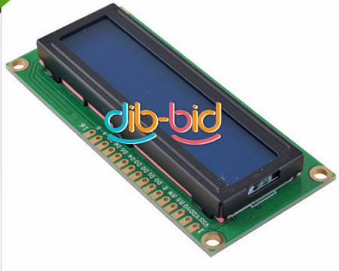



<http://magnusglad.wordpress.com/tag/lcm1602/>

[Good UNO article - adafruit](https://learn.adafruit.com/character-lcds/rgb-backlit-lcds)

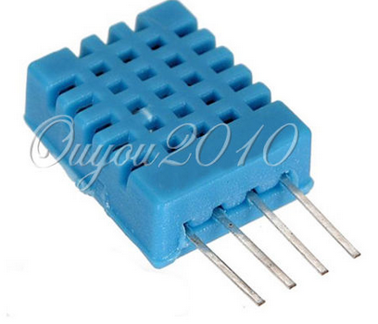



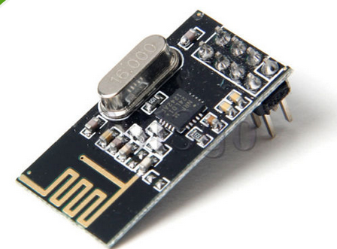



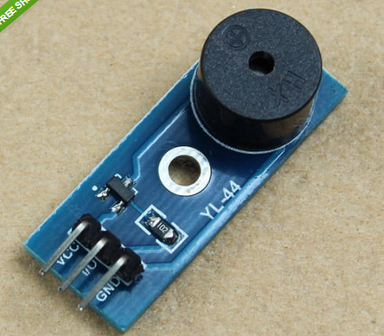



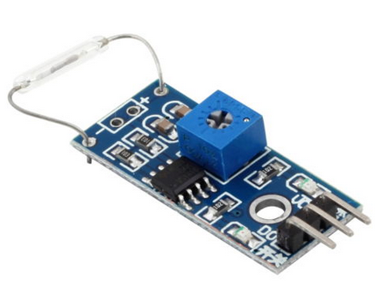



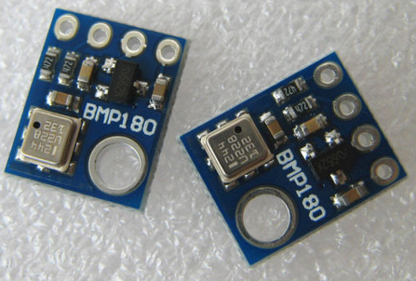



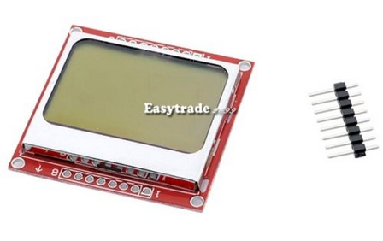



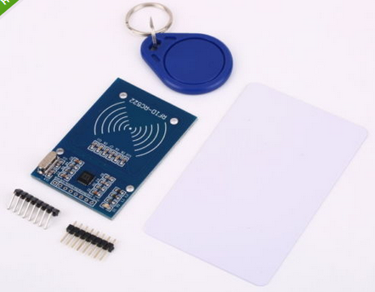



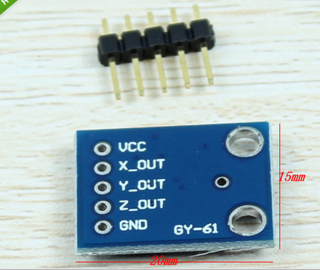

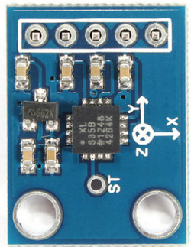



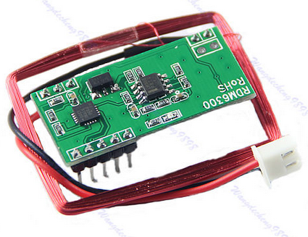







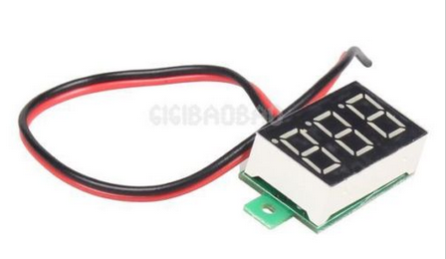



]

**Microwave Doppler X-Band Radar Detector Wireless Module Move Motion Speed Sensor**

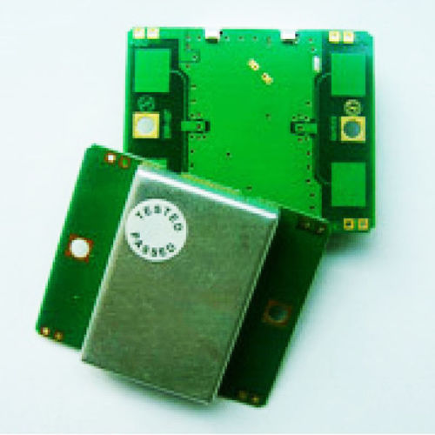

**5V-12V LM386 Audio Amplifier Module 200 Times Input 10K Adjustable Resistance**

